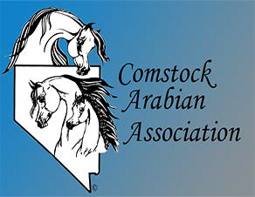

2024 Comstock Arabian Association Spring Fiesta Value Horse Show
May 3-5, 2024, Reno-Sparks Livestock Events Center
Sponsorship Form
Sponsor Name: Business/Farm Name:

Address: City: State: Zip:

Telephone: Email:
Gold Sponsorship: $300.00 x = $
Includes Full Page Color Ad in Program, 1 Banner Display in Main Arena, 4 championship class sponsors & 2 regular class sponsors
Silver Sponsorship: $200.00 x = $
Includes Full Page Color Ad in Program, Banner Display in Main Arena, 2 championship class sponsors & 2 regular class sponsors
Platinum Sponsorship: $100.00 x = $
Includes Full Page Black & White Ad in program, 1 championship class sponsor, & 1 regular class sponsor
Back Cover Full Page Color Ad - 11" x 8":
Half Page Color Ad - 5.5" x 8":
Half Page Black & White Ad - 5.5" x 8":
Championship Class Sponsor:
Regular Class Sponsor:
$250.00 x = $
$40.00 x = $
$30.00 x = $
$60.00 x = $
$40.00 x = $
______Business Card Size Ad: $10.00 x = $
Color OR Black and White camera-ready ads (.jpg or .pdf file ONLY) Management reserves the right to refuse any ad not camera ready
Sponsor Selection, Ad or Business Card and Payment
Appreciated by April 19, 2024 to:
Dawn Staudt-Vanek
1117 Cortez Lane
Gardnerville, NV 89410
(Questions: jdvanek@hotmail.com or 408-375-1041)
If sponsoring a class and prefer to sponsor a specific class number, please add the class number below.
Academy Class(es) Amateur Class(es) Dressage Class(es) English Class(es) Halter Class(es) Junior Class(es) Open Class(es) Sport Horse Class(es) Western Class(es)
*Please do not write below
Business Card enclosed Camera Ready Ad Enclosed Check # Amount enclosed $
Non Profit NR C 1481-1965 Nevada

